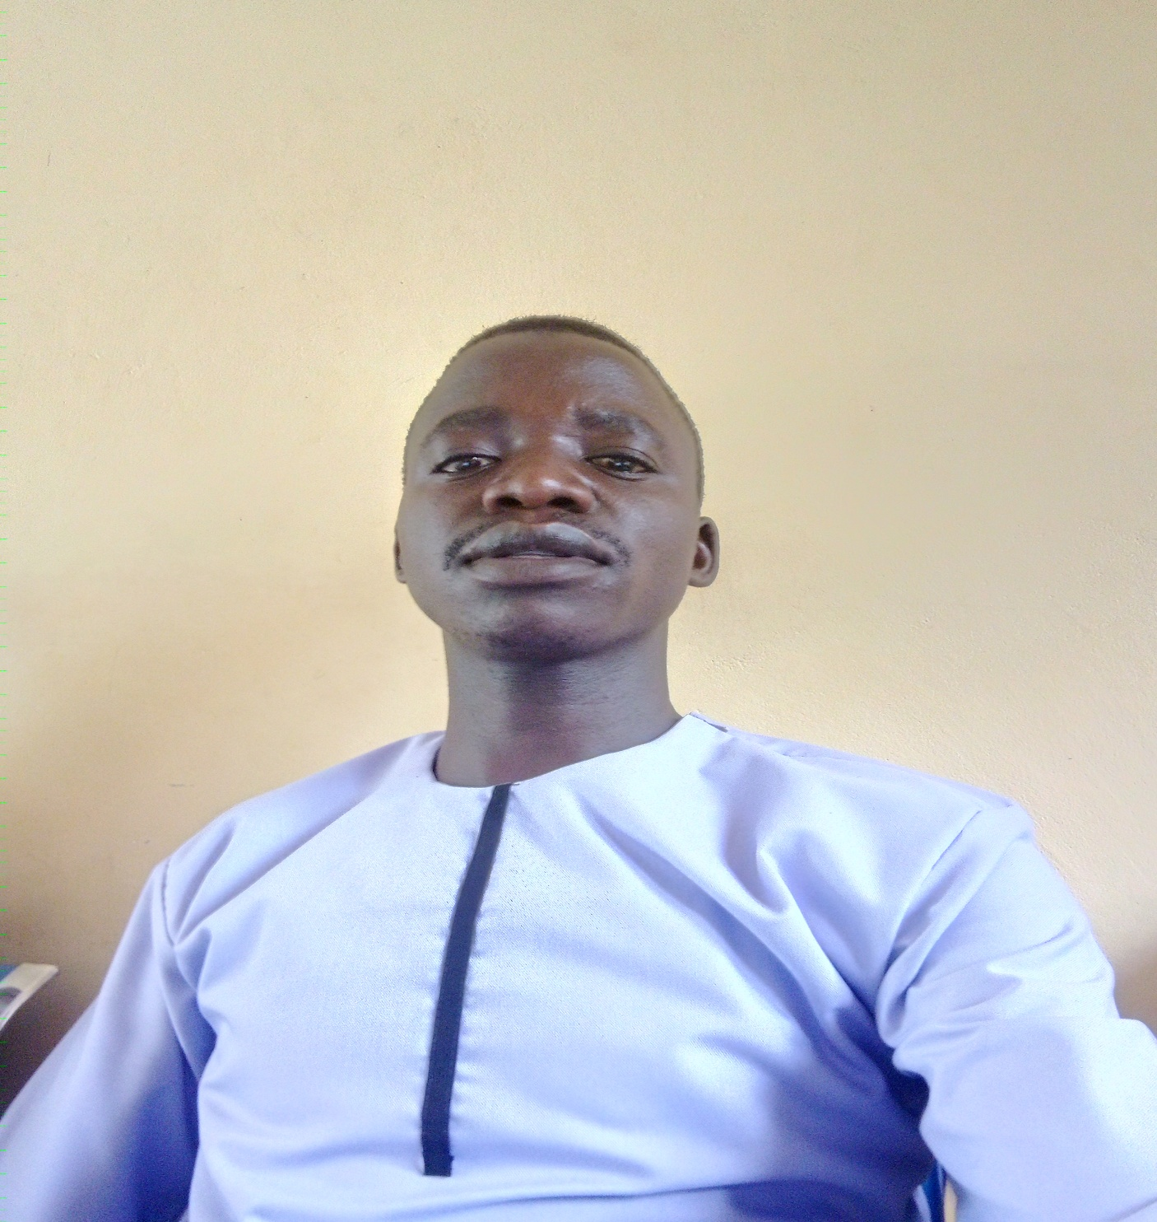

**MR. OCEN DANIEL**

**MY POWERFUL MESSAGE OF THE DAY**

**I tasted all that is sweet but I found nothing sweeter than good health. I tasted all**

**That is bitter but nothing was more bitter than being in need of good people.**

**I carried both iron and rocks but I found nothing more heavier than debts. I discovered that life has two only two days. A day for you and a day against you.**

**So, when it is a day for you, don’t be reckless and when is a day against you, be patient because both days will expire, they are not permanent.**

**If you can’t be a bridge to connect people, don’t be a wall to separate people. If you can’t be a light to brighten people’s good deeds then don’t be a darkness covering their efforts and tarnishing their names. If you can’t be vaccine to give life to people then don’t be a virus to terminate it.**

**We can only be each other’s keepers.**

**United we stand to achieve the goals**

**Thanks**